Name:

Matric No:

**Sentiment Analysis using Python**

1. Go to <https://colab.research.google.com/>

Log in using your Google Account.

1. Go to <https://github.com/shikinsamat/SA>

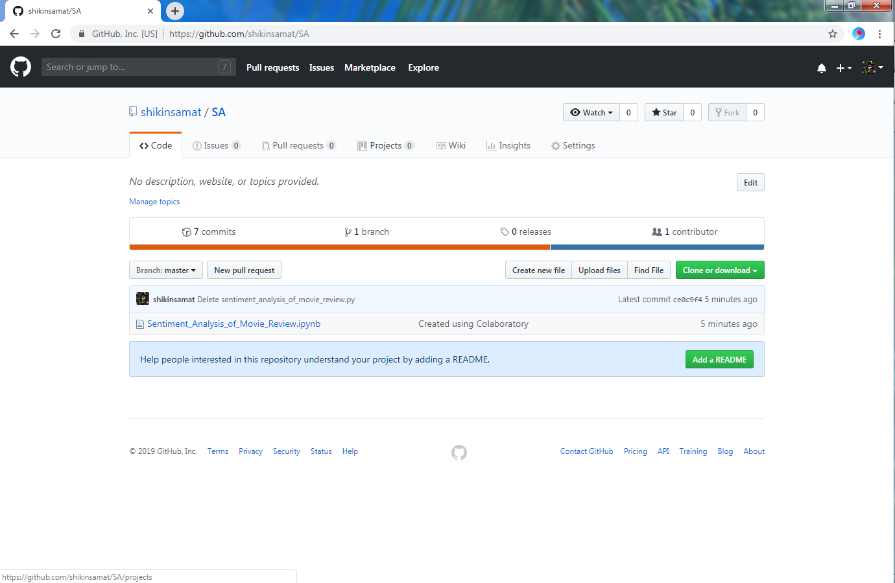

Click  , Download ZIP file and unzip the file.

1. Upload and Run *Sentiment_Analysis_of_Movie_Review.ipynb* file in Google Colab.
2. Lab Exercise:

Find 10 reviews from Internet and find the sentiment analysis from it.